Technical Documentation

Happy Mats Project

Peter Joraoul A. Parungao

Mary Grace M. Rivero

CERTIFIED

**CERTIFICATE OF AUTHORSHIP**

We hereby certify that this submission Project for CS123 abides by the principles stipulated in the DISCS’ Academic Integrity Policy document. We further certify that we are the authors of this program/ project/ report/ paper and that any assistance we received in its preparation is fully acknowledged and disclosed in the documentation. We have also cited all sources from which we obtained data, ideas, or words that are directly copied or paraphrased in this document. Sources are properly credited according to accepted standards for professional publication.

\_\_\_\_\_\_\_\_\_\_\_\_\_\_\_\_\_\_\_ \_\_\_\_\_\_\_\_\_\_\_\_\_\_\_\_\_\_\_

Peter Joraoul Parungao Mary Grace M. Rivero

Submitted to: Mr. Raphael Alampay

Date of Submission: Oct. 15, 2014

As required in: CS123 Software Engineering  
Sources:

Table of Contents

I. Statement of Work 4

II. Data Flow Diagram 5

III. Entity-Relationship Model 7

IV. Data Dictionary 10

V. Usecase Diagram 13

Revision History 13

Use Case List 14

Inventory Viewing 14

Sales Report 15

Adding Purchasing Records 15

Viewing Purchasing Records 16

Register Products Details 17

VI. Project Source Code 19

VIII. Appendix 19

Approvals 19

Resumes 20

# I. Statement of Work

|  |  |
| --- | --- |
| Thunders |  |

Project Name: Central Inventory Management System (CIMS)

TG Project Manager: Peter Joraoul A. Parungao

Customer: Happy Mats

Project Sponsor: Jennifer Saret

TG Development Staff Estimates (man-hours)

* Peter Joraoul A. Parungao (Developer) : 90
* Mary Grace Miranda (Developer): 90

|  |  |
| --- | --- |
| Project Description |  |

Goals

* This project will implement an inventory management system to keep for the whole company. The purpose of the system is to keep track of services, sales and inventory of all company sites to reduce paper work and to keep updated information to the manager and its management

Objectives

* Provide updated information of sales and inventory
* Provide reports for inventory status and sales trends.

# II. Data Flow Diagram

The following diagram will explain the data flow inside the current system of the Happy Mats Furniture Merchandise. Level 1 shows how data from Client will be recorded in their manual journals and all the details of the purchase from the supplier. Level 2 will show how they manage and check their Inventory by conducting an Inventory Inspection and knowing if it needs a re-supply. Level 2 will explain how the Inspection is conducted.

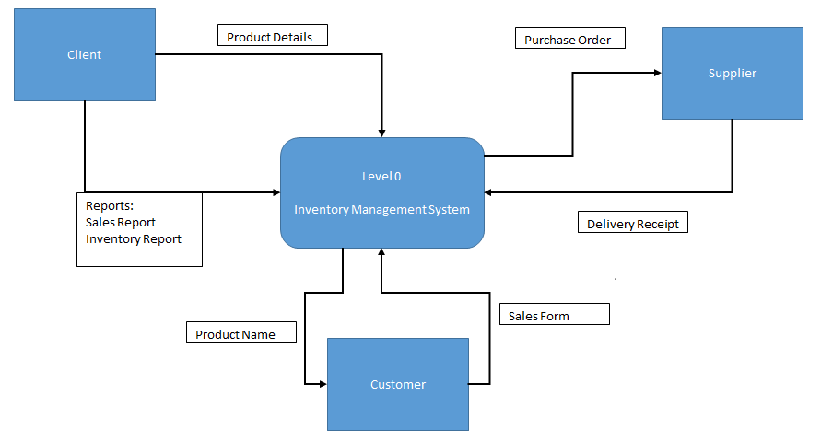

Figure 1: DFD Level 0

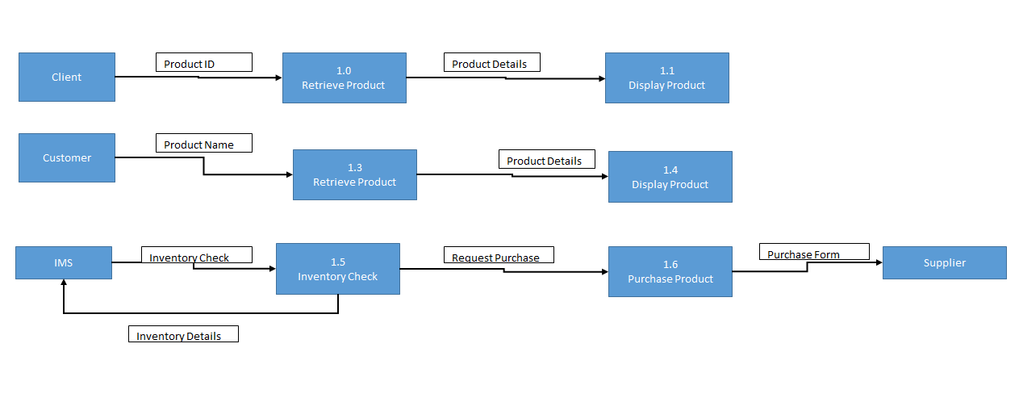

Figure 2: DFD Level 1

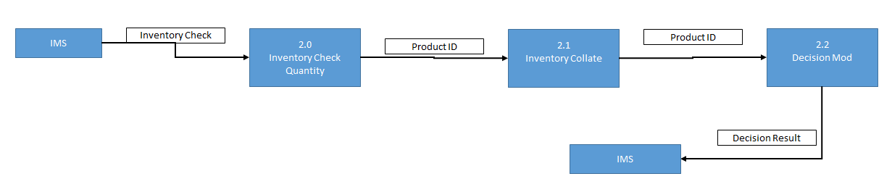

Figure 3: DFD Level 2

# III. Entity-Relationship Model

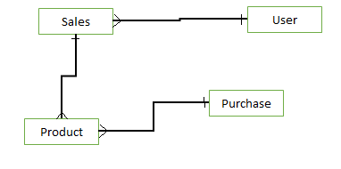

Figure 4: Entity-Relationship Diagram

The Figure 4 shows that the inventory management system is composed of four main tables, namely: Sales, User, Product, and Purchase. The User has one is to many relationship with Sales and Sales has many is to one relationship with User. This means that one user can input as many sales as he can.

Sales one is to many relationship with Products and Products has many is to one relationship with Sales. This means that in each entry in the sales tables, there can be a lot of products involved or inputted with it.

Products has many is to one relationship with purchase and Purchase has one is to many relationship with Products. This also means that in one purchase entry, there can be a lot of products in it.

Summary:

USER | 1 – MANY | SALES

SALES | MANY – 1 | USER

SALES | 1 – MANY | PRODUCTS

PRODUCTS| MANY – 1 | SALES

PRODUCTS | MANY – 1 | PURCHASE

PURCHASE | 1 – MANY | PRODUCTS

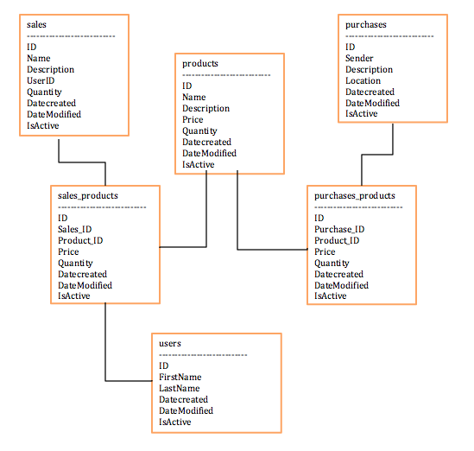

Figure 5: Entity Relationship Diagram Details

Figure 5 shows the attributes in each table. As one can see, each table has the “IsActive” attribute because the team believes that the integrity of the data will be preserved if we would not really delete an item but instead make use of the IsActive attribute of it. IsActive is a bit. We would just assign 0 as false, which entails that the item is inactive, otherwise if it is 1, then it is active. At the start, the default value that is set for IsActive is 1. A more detailed description, data type, length and constraint/rule of each attribute are identified in the next tables. These tables contain the data dictionary of the inventory system—how the database is designed.

# IV. Data Dictionary

|  |  |  |  |
| --- | --- | --- | --- |
| **Entity** | Product |  |  |
| **Table name** | Products |  |  |
| **Attribute** | **Data Type** | **Length** | **Constrait/ Rule** |
| ID | INTEGER | database default [-2,147,483,647 to 2,147,483,647] | PK, UNIQUE, NOT NULL, AUTO-INCREMENT 1 start at 0) |
| Name | VARCHAR | 10 | NOT NULL |
| Description | VARCHAR | 255 | NOT NULL |
| Quantity | INTEGER | database default [0 to 2,147,483,647] | NOT NULL |
| Price | INTEGER | database default [0 to 2,147,483,647] | NOT NULL |
| DateCreated | DATE TIME | database default date length | dateadd(hh,getutcdate(),8) |
| DateModified | DATE TIME | database default date length | dateadd(hh,getutcdate(),8) |
| IsActive | BIT | 1 | [0,1] 0 = Not Active, 1 = Active: default = 1 |

|  |  |  |  |
| --- | --- | --- | --- |
| **Entity** | Purchase |  |  |
| **Table name** | Purchases |  |  |
| **Attribute** | **Data Type** | **Length** | **Constrait/ Rule** |
| ID | INTEGER | database default [-2,147,483,647 to 2,147,483,647] | PK, UNIQUE, NOT NULL, AUTO-INCREMENT 1 start at 0) |
| Sender | VARCHAR | 255 | NOT NULL |
| Description | VARCHAR | 255 | NOT NULL |
| Location | VARCHAR | 255 | NOT NULL |
| DateCreated | DATE TIME | database default date length | dateadd(hh,getutcdate(),8) |
| DateModified | DATE TIME | database default date length | dateadd(hh,getutcdate(),8) |
| IsActive | BIT | 1 | [0,1] 0 = Not Active, 1 = Active: default = 1 |

|  |  |  |  |
| --- | --- | --- | --- |
| **Entity** | Purchase\_Record |  |  |
| **Table name** | purchases\_records |  |  |
| **Attribute** | **Data Type** | **Length** | **Constrait/ Rule** |
| ID | INT | database default [-2,147,483,647 to 2,147,483,647] | PK, UNIQUE, NOT NULL, AUTO-INCREMENT 1 start at 0) |
| Purchase\_ID | INT | database default [-2,147,483,647 to 2,147,483,647] | FK, primary in purchase.id, NOT NULL |
| Record\_ID | INT | database default [-2,147,483,647 to 2,147,483,647] | FK, primary in record.id, NOT NULL |
| Price | INTEGER | database default [0 to 2,147,483,647] | NOT NULL |
| Quantity | INT | database default [-2,147,483,647 to 2,147,483,647] | NOT NULL |
| DateCreated | DATE TIME | database default date length | dateadd(hh,getutcdate(),8) |
| DateModified | DATE TIME | database default date length | dateadd(hh,getutcdate(),8) |
| IsActive | BIT | 1 | [0,1] 0 = Not Active, 1 = Active: default = 1 |

|  |  |  |  |
| --- | --- | --- | --- |
| **Entity** | User |  |  |
| **Table name** | users |  |  |
| **Attribute** | **Data Type** | **Length** | **Constrait/ Rule** |
| ID | INT | database default [-2,147,483,647 to 2,147,483,647] | PK, UNIQUE, NOT NULL, AUTO-INCREMENT 1 start at 0) |
| FirstName | VARCHAR | 255 | NOT NULL |
| LastName | VARCHAR | 255 | NOT NULL |
| DateCreated | DATE TIME | database default date length | dateadd(hh,getutcdate(),8) |
| DateModified | DATE TIME | database default date length | dateadd(hh,getutcdate(),8) |
| IsActive | BIT | x | [0,1] 0 = Not Active, 1 = Active: default = 1 |

|  |  |  |  |
| --- | --- | --- | --- |
| **Entity** | Sales |  |  |
| **Table name** | sales |  |  |
| **Attribute** | **Data Type** | **Length** | **Constrait/ Rule** |
| ID | INTEGER | database default [-2,147,483,647 to 2,147,483,647] | PK, UNIQUE, NOT NULL, AUTO-INCREMENT 1 start at 0) |
| Description | VARCHAR | 255 | NOT NULL |
| User\_ID | INTEGER | database default [-2,147,483,647 to 2,147,483,647] | FK, primary in users.id, NOT NULL |
| Location | VARCHAR | 255 | NOT NULL |
| DateCreated | DATE TIME | database default date length | dateadd(hh,getutcdate(),8) |
| DateModified | DATE TIME | database default date length | dateadd(hh,getutcdate(),8) |
| IsActive | BIT | 1 | [0,1] 0 = Not Active, 1 = Active: default = 1 |

|  |  |  |  |
| --- | --- | --- | --- |
| **Entity** | Sales\_Product |  |  |
| **Table name** | sales\_products |  |  |
| **Attribute** | **Data Type** | **Length** | **Constrait/ Rule** |
| ID | INT | database default [-2,147,483,647 to 2,147,483,647] | PK, UNIQUE, NOT NULL, AUTO-INCREMENT 1 start at 0) |
| Sales\_ID | INT | database default [-2,147,483,647 to 2,147,483,647] | FK, primary in sales.id, NOT NULL |
| Record\_ID | INT | database default [-2,147,483,647 to 2,147,483,647] | FK, primary in record.id, NOT NULL |
| Quantity | INT | database default [-2,147,483,647 to 2,147,483,647] | NOT NULL |
| Price | INT | database default [-2,147,483,647 to 2,147,483,647] | NOT NULL |
| DateCreated | DATE TIME | database default date length | dateadd(hh,getutcdate(),8) |
| DateModified | DATE TIME | database default date length | dateadd(hh,getutcdate(),8) |
| IsActive | BIT | 1 | [0,1] 0 = Not Active, 1 = Active: default = 1 |

# V. Usecase Diagram

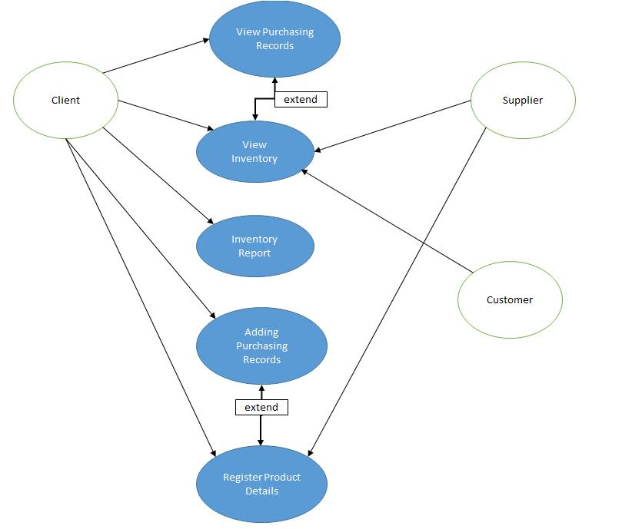

## Revision History

| **Version** | **Date** | **Revision Description** |
| --- | --- | --- |
| 1.0 | Aug. 12, 2014 | Initial Description |
|  |  |  |
|  |  |  |
|  |  |  |
|  |  |  |
|  |  |  |
|  |  |  |

## 

## Use Case List

|  |  |  |
| --- | --- | --- |
| **Use Case ID** | **Primary Actor** | **Use Cases** |
| UC-MS-001 | User | Inventory Viewing |
| UC-MS-002 | User | Inventory Report |
| UC-MS-003 | User | Adding Purchasing Records |
| UC-MS-004 | User | Viewing Purchasing Records |
| UC-MS-005 | User | Register Products Details |

### Inventory Viewing

|  |  |  |  |  |
| --- | --- | --- | --- | --- |
| **Use Case ID:** | UC-MS-001 | | | |
| **Use Case Name:** | Inventory Viewing | | | |
| **Created By:** | Peter Parungao | | **Last Updated By:** |  |
| **Date Created:** |  | | **Last Revision Date:** |  |
| **Actors:** | | User | | |
| **Description:** | | User will have the ability to view details of specific Inventory | | |
| **Trigger:** | | User is required to check the status of a product | | |
| **Preconditions:** | | Product must be in ownership of the company  Product Code or Product Name for input is correct. | | |
| **Postconditions:** | | User is able to view the details of the Inventory  User is notified if the product is not available in the system | | |
| **Normal Flow:** | | 1. User provides product ID or Product Name 2. System checks if the product exists    1. If product does not exist, display a Notification. 3. System retrieves product details and display in an UI if the product exists | | |
| **Alternative Flows:** | |  | | |
| **Exceptions:** | | 1. When System Connection issue, the User is notified that the connection is unavailable. 2. Notification for errors if the user inputs a code outside the following rules:   Product Code  1. Must have at least 5 Alphanumeric keys  2. Must follow product category for the naming of product code.  3. Must not be null.  Product Name:  1. Must not contain numbers.  2. Must not be null. | | |
| **Includes:** | |  | | |
| **Frequency of Use:** | | 100 per day | | |
| **Special Requirements:** | | Product Code must follow the agreed product coding standards set by the Client | | |
| **Assumptions:** | | The Client/User understands English/Tagalog  The Client/User has basic Understanding of User Interfaces.  The Client/User has basic computer literacy | | |
| **Notes and Issues:** | |  | | |

### Sales Report

|  |  |  |  |  |
| --- | --- | --- | --- | --- |
| **Use Case ID:** | UC-MS-002 | | | |
| **Use Case Name:** | Sales Report | | | |
| **Created By:** | Peter Parungao | | **Last Updated By:** |  |
| **Date Created:** |  | | **Last Revision Date:** |  |
| **Actors:** | | User | | |
| **Description:** | | Inventory Report | | |
| **Trigger:** | | User is in need to view the status of all products in the Inventory | | |
| **Preconditions:** | | Products exists in the Inventory  User has an application that can open CSV files | | |
| **Postconditions:** | | User will receive a CSV generated file containing the Report | | |
| **Normal Flow:** | | 1. User will activate the Report Button Function on the UI 2. User will then select the destination of the file 3. User will receive the CSV Generated File | | |
| **Alternative Flows:** | |  | | |
| **Exceptions:** | | No connection on the database  Sufficient disk space on the computer being used.  System Notification if the directory location is unavailable. | | |
| **Includes:** | |  | | |
| **Frequency of Use:** | | On demand | | |
| **Special Requirements:** | |  | | |
| **Assumptions:** | | Database is set up  User has basic Computer Literacy on using CSV files | | |
| **Notes and Issues:** | |  | | |

### Adding Purchasing Records

|  |  |  |  |  |
| --- | --- | --- | --- | --- |
| **Use Case ID:** | UC-MS-003 | | | |
| **Use Case Name:** | Adding Purchasing Records | | | |
| **Created By:** | Mary Rivero | | **Last Updated By:** |  |
| **Date Created:** |  | | **Last Revision Date:** |  |
| **Actors:** | | User | | |
| **Description:** | | Adding Purchasing Records | | |
| **Trigger:** | | Purchase Order has been received | | |
| **Preconditions:** | | Product ID is valid in the System  Inventory is Low | | |
| **Postconditions:** | | User will receive notification that the Purchase has been successfully added in the System’  User will also get a notification if the details are input incorrectly. | | |
| **Normal Flow:** | | 1. User opens the form for adding purchasing order details 2. User input the necessary details for the purchasing order 3. User saves the work 4. System will save the details to the database 5. The Application will notify the user of the successful transaction | | |
| **Alternative Flows:** | |  | | |
| **Exceptions:** | | 1. No connection on the database 2. Sufficient database space on the computer being used. 3. Input details incorrect and does not con | | |
| **Includes:** | |  | | |
| **Frequency of Use:** | | On demand | | |
| **Special Requirements:** | |  | | |
| **Assumptions:** | | Database is set up  User has basic Computer Literacy on using User Interfaces | | |
| **Notes and Issues:** | |  | | |

### Viewing Purchasing Records

|  |  |  |  |  |
| --- | --- | --- | --- | --- |
| **Use Case ID:** | UC-MS-004 | | | |
| **Use Case Name:** | Viewing Purchasing Records | | | |
| **Created By:** | Peter Parungao | | **Last Updated By:** |  |
| **Date Created:** |  | | **Last Revision Date:** |  |
| **Actors:** | | User | | |
| **Description:** | | User will have the ability to view details of specific Purchasing record | | |
| **Trigger:** | | User is required to check the status of a product | | |
| **Preconditions:** | | Purchase must be in ownership of the company  Purchase Code or Purchase Name for input is correct | | |
| **Postconditions:** | | User is able to view the details of the Purchase  User is notified if the Purchase is not available in the system | | |
| **Normal Flow:** | | 1. User provides Purchase ID or Purchase Name 2. System checks if the product exists 3. If Purchase does not exist, display a Notification. 4. System retrieves product details and display in an UI if the Purchase exists | | |
| **Alternative Flows:** | |  | | |
| **Exceptions:** | | 1. When System Connection issue, the User is notified that the connection is unavailable. | | |
| **Includes:** | |  | | |
| **Frequency of Use:** | | 100 per day | | |
| **Special Requirements:** | | Product Code must follow the agreed Purchase Identification coding standards set by the Client | | |
| **Assumptions:** | | The Client/User understands English/Tagalog  The Client/User has basic Understanding of User Interfaces.  The Client/User has basic computer literacy | | |
| **Notes and Issues:** | |  | | |

### Register Products Details

|  |  |  |  |  |
| --- | --- | --- | --- | --- |
| **Use Case ID:** | UC-MS-005 | | | |
| **Use Case Name:** | Register Products Details | | | |
| **Created By:** | Mary Rivero | | **Last Updated By:** |  |
| **Date Created:** |  | | **Last Revision Date:** |  |
| **Actors:** | | Manager (Primary) | | |
| **Description:** | | Input product details | | |
| **Trigger:** | | 1. There is a new product that is not yet in the product list  2. Product list is empty. | | |
| **Preconditions:** | | 1. There is a product that has been faced out. | | |
| **Postconditions:** | | 1. System will contain product details. 2. Products will be updated. | | |
| **Normal Flow:** | | 1. Manager enters a valid product code 2. Manager enters a valid name of the product 3. Manager enters a valid price of the Product 4. Manager enters quantity of the product 5. Manager hits save button. 6. Manager views product details for checking. | | |
| **Alternative Flows:** | | 4a. In step 4 of the normal flow, if the customer is not in the bank network   1. System will prompt customer to accept network fee 2. Customer accepts 3. Use Case resumes on step 5   4b. In step 4 of the normal flow, if the customer is not in the bank network   1. System will prompt customer to accept network fee 2. Customer declines 3. Transaction is terminated 4. Use Case resumes on step 9 of normal flow | | |
| **Exceptions:** | | 1a. In step 1 of the normal flow, if the manager enters an invalid product code  A prompt message will appear saying, “Please input a valid product code”  System lets manager enter a valid product code.  Manager enters a valid product code.  Use Case resumes on step 2 of normal flow.  2a. In step 2 of the normal flow, if the manager enters an invalid product name.  A prompt message will appear saying, “Please input a valid product name”.  System lets manager enter a valid product name.  Manager enters a valid product name.  Use Case resumes on step 3 of normal flow.  3a. In step 2 of the normal flow, if the manager enters an invalid product price.  A prompt message will appear saying, “Please input a valid product price”.  System lets manager enter a valid product price.  Manager enters a valid product price.  Use Case resumes on step 4 of normal flow.  4a. In step 2 of the normal flow, if the manager enters an invalid product price.  A prompt message will appear saying, “Please input valid quantity”.  System lets manager enter a valid quantity.  Manager enters a valid quantity.  Use Case resumes on step 5 of normal flow.   1. Error notification if the User input does not follow the said rules:   Product Code  1. Must have at least 5 Alphanumeric keys  2. Must follow product category for the naming of product code.  3. Must not be null.  Product Name:  1. Must not contain numbers.  2. Must not be null.  Product Price  1. Must not contain letters  2. Must be a positive integer.  3. Must not be null.  Product Quantity  1. Must contain numbers only  2. Must be a positive integer.  3. Must be whole numbers.  4. Must not be null. | | |
| **Includes:** | | 1.3 Viewing of products | | |
| **Frequency of Use:** | | Twice a month: Start of the month and middle of the month. | | |
| **Special Requirements:** | |  | | |
| **Assumptions:** | | Products exist. | | |
| **Notes and Issues:** | | Product Code  1. Must have at least 5 Alphanumeric keys  2. Must follow product category for the naming of product code.  3. Must not be null.  Product Name:  1. Must not contain numbers.  2. Must not be null.  Product Price  1. Must not contain letters  2. Must be a positive integer.  3. Must not be null.  Product Quantity  1. Must contain numbers only  2. Must be a positive integer.  3. Must be whole numbers.  4. Must not be null. | | |

# VI. Project Source Code

The source code of the inventory management system for Happy Mats can be downloaded from GitHub at this link:

[https://github.com/pparungao/CS123Project](https://github.com/pparungao/CS123Project" \t "_blank)

# VIII. Appendix

## Approvals

We have carefully assessed the Use Cases for this project. This document has been completed in accordance with the requirements of the System Development Methodology.

MANAGEMENT CERTIFICATION - Please check the appropriate statement.

\_\_\_\_\_\_ the document is accepted.

\_\_\_\_\_\_ the document is accepted pending the changes noted.

\_\_\_\_\_\_ the document is not accepted.

We fully accept the changes as needed improvements and authorize initiation of work to proceed. Based on our authority and judgment, the continued operation of this system is authorized.

(\*=Required \*\*= Submit for Review Approval Not Required)

Jennifer Jade Saret October 15, 2014

Client DATE

Project Sponsor\* DATE

Quality Assurance Manager / Team Lead\* DATE

Business Analyst Manager / Team Lead\* DATE

Project Manager DATE

Resumes

Peter Joraoul A. Parungao

35 Don Senen St., Don Antonio Heights,

Brgy. Holy Spirit, Quezon City

Telephone No.: 951-8761

Mobile No.: (927) 325-4969

E-mail address:[*pjparungao@gmail.com*](mailto:pjparungao@gmail.com)

**PROFESSIONAL OBJECTIVE**

**Seeking a challenging position where I could utilize my mathematical and computer skills and be part of a work environment that will further develop the full potential of my abilities.**

***Technical Skills***

1. Proficient in MySQL, MSSQL 2000 – 2008 R2, ORACLE.
2. Proficient in VB.NET, ASP.Net and .NET 2.0 framework and above
3. Proficient in Android Mobile Development
4. Exposure on MS -Silverlight, VB6, C#.NET, Java, Javascript, XML, HTML, Crystal Reports
5. Proficient on using MS VS 2005 – MS VS 2010, Eclipse

**WORK EXPERIENCE**

**May 2011 up to Present**

***MIS Developer***

***NCO – Expert Global Solutions (EGS)***

* Applied fixes to the current system that increased the efficiency of loading the initial data and brought about a quantifiable decrease in the loading time up to 70 – 95%.
* Redesigned database and coding structure of a Ticketing system that enhanced the effectiveness of user sessions and speed that greatly improved user service and workforce scheduling.
* Maintained and Improved support applications used for Timekeeping, Leave and Overtime tracking, Employee Records and movements and New Hire Tracking.
* Developed an application using an SMS modem intended to send out emergency text messages for Business Continuity Processes
* Developed a web based Employee Tracking that handles online submissions and approvals using Javascript, Java , Crystal Reports, SQL and .NET Technology that reduced delayed employee movement turnover up to 70%.
* Developed a web based Time keeping System that services more than 10,000 users using Javascript, SQL and .NET Technology.
* Introduced OOP methods that promoted maintainability of the source codes and increased the efficiency of all algorithms in the system.
* Part of 6 man team that converted the current applications into a Web Based system.
* Generated and automated reports critical for Payroll, SAP Organization Management and HR.
* Integrated databases of merging companies with minimal downtime.
* Improved security and validations for applications that enforced data integrity.
* Automated Employee movements that minimized the number of delayed company movements and minimized paper routing using applications with integrated Crystal Reports.
* Successfully published critical updates well within the deadlines and fully supported the initial deployment phase.

**August 2010 up to May 2011**

***Software Developer***

***FILMETRICS Corporation – BDSF***

* Develop Programs for validating demographics, *Images* and *WSQ* (fingerprints) files using VB.NET, MSSQL, ORACLE, MS ACCESS and Third Party Softwares (SDKs
* Created a Prototype Inventory Management System for Equipment and Employees with MYSQL and ASP.NET(Windows Application)
* Coordinates and monitors troubleshooting and provides solutions to technical problems faced by the employees/company
* Handled Documentations on Data Analysis, High Level Designs, Database Structure of programs developed for the Company

**March 2009 up to July 2010**

***System Analyst and Programmer***

***Planters DB Properties Inc.***

* Updated Manual on Policies and Procedures for a Realty-based company
* Designed and supervised database management that minimized system errors and maximized web capabilities
* Designed User Interfaces using Photoshop and other Image Editing tools
* Developed a prototype Realty based Inventory system and participated in both operational analysis and software development using ASP.NET and MYSQL
* Responsible for interacting with the customers and employees to understand their requirements and suggestions
* Provided data analysis, documentation to map data, workflow, and processes from different sources.
* Collaborated with the designs of marketing division that helped increased on sales and feedback returns
* Coordinated and monitored troubleshooting and provided solutions to technical problems faced by the employees
* Handled and supervised Network Maintenance

**2008 to 2009**

***Tutor and Reviewer***

***Brain-Train Review Center (Los Baños)***

* Supervised eight review classes in mathematics daily, with 30 to 40 students per class who were preparing for UPCAT and entrance exams to PSHS/UPHRS and other top educational institutions.
* Assisted customer service and helped give out information to guests and potential clients.

**THESIS WORK**

***Data Mining Sensor Project(2014 DOST - Ateneo)***

* Part of the team that will handle system requirements and data gathering and play a vital role in designing and programming the mobile and database/web development.

**EDUCATIONAL BACKGROUND**

**2013 to present**

**Master in Information and Technology**

**Ateneo de Manila University**

**2004 to 2009**

**Bachelor of Science in Mathematics**

**University of the Philippines**-**Los Baños**

****

Mary Grace M. Rivero

62-A Darter Terrace, West Kalayaan, Subic Bay Freeport Zone ♦ 09173198989 ♦ mary.rivero@obf.ateneo.edu

**JOB OBJECTIVE**

To gain an enriching experience where I can contribute in the areas of **computer and IT, research and development, human resources** and other related openings.

**EDUCATION**

**Ateneo de Manila University**

*Masters in Information Technology (SOSE) Present*

*Bachelor of Science in* ***Legal Management,*** *Minor in* ***Information Technology Management (JGSOM)***

*Scholar June 2009 – March 2013*

**Grade School Class Salutatorian** *March 2005*

**CO-CURRICULAR ACTIVITIES**

**Ateneo Women’s Lawn Tennis Team | Team Captain (***2011-2014***)** *2009-Present*

*Varsity team representing AdMU in UAAP, UniGames, Philippine Columbian Association, Intercollegiate Tournament, etc.*

*Helped the team achieve its one of the highest attainment in UAAP Tennis in the history of the Ateneo (2nd Place in Season 73)*

**Ateneo Lex (LEX)** *2009-2013*

*Home organization of students in the Legal Management Program*

• *Active member of the organization*

*Participated in the events such as Lex Bazaars, JGSOM Games (played for LEX), Business Law Conference, etc.*

**WORK-RELATED EXPERIENCE**

**Project Officer, College Athletics Office**

• *As Project Officer, I handle academic related affairs of the student athletes of Ateneo de Manila University. I am also part of the team who organizes the events of athletes such as Cheer Rally, Send-off Mass of athletes, Athletes’ Night and Bonfire.*

**Internship, Ateneo Java Wireless Competency Center (AJWCC)** *September 2013-Present*

• *Assisted in the projects like eHEALTH Tablet, eHatid and Ascent*

*• Started with the Respond, a project for Psychological Association of the Philippines for the monitoring of their volunteers*

**Cake Blends, Leadership and Strategy Project** *2012-Present*

• *As* ***Co-Owner****, oversees the daily operations, Logistics and Research and Development of the business*

*• In-charge of knowing the trends in the market as well as product innovations*

**Francis Merchandising, Family Owned Company**

* *Had a sort of internship at our own company during the summer of 2012. I administered the daily operations as well as organized and managed the inventory of the business by introducing applications like the InFlow inventory system to help easily manage the company’s inventory.*

**Duets for Del Monte, Marketing Project**

* *Co-creator of the business plan and market research for our Marketing102 Project.*

**AWARDS**

**Individual**:

MVP Player of the year of the Ateneo Women’s Lawn Tennis Team (2013), Reached Semi-Finals in the **1st Asean University Championship** held in **Perlis, Malaysia** (2011), **Ranked No. 7** in the Philippine Tennis Association in the 18-under Girls Category (2010)

**Team:**

2nd Place in the UAAP Season 73, 3rd Place in the UAAP Season 72, 2nd Place in Philippine Columbian Association Intercollegiate Tournament, 2nd Place in Milo Intercollegiate Tournament

**SKILLS & INTERESTS**

Fluent in English and Filipino and I also understand basic Japanese. Proficient in MS Office, I like exploring the web or any applications related to computers and other technologies. Adventurous, I like traveling with family and friends and I enjoy being spontaneous and going with the flow. I love watching series and going on a food trip more than shopping. I am observant as people might say because it is a hobby of mine that when I meet new people, I like to know whether they are left handed or right handed just by observing them. I am very athletic, I like trying different sports. It has helped me discipline myself, have good time management skill which all has made me a balanced and a well-rounded type of person.